Data Analytics

**Pandas**

Pandas is a Python library used for working with data sets. It has functions for analyzing, cleaning, exploring, and manipulating data.

Pandas is a powerful and open-source Python library. The Pandas library is used for data manipulation and analysis. Pandas consist of data structures and functions to perform efficient operations on data.

Pandas is well-suited for working with tabular data, such as spreadsheets or SQL tables.

The name "Pandas" has a reference to both "Panel Data", and "Python Data Analysis" and was created by Wes McKinney in 2008.

Pandas allows us to analyze big data and make conclusions based on statistical theories.

Pandas can clean messy data sets, and make them readable and relevant.

Relevant data is very important in data science.

**Steps**

1. Open Anaconda Prompt
2. Type ‘jupyter notebook’
3. It will redirect to Home page of Jupyter notebook on browser
4. In Files tab open Desktop folder
5. Create new folder using New button on top right and name it
6. Open the folder and click on Upload button
7. Upload the dataset file (.csv , .xlsv) on which you have to perform tasks
8. Create a Python file by clicking on new button and choosing ‘Python 3’ file
9. On creating, file will open in new tab of the browser
10. Import pandas
11. Store dataset file in a variable

**Perform the following operations**

Before performing tasks on dataset we need to

1. **Import pandas:**

import pandas as pd

1. **Store dataset file in a variable:**

ds = pd.read_csv("StudentsPerformance.csv")

**Q.1. Display first 5 rows of dataset.**

**Ans:** ds.head()

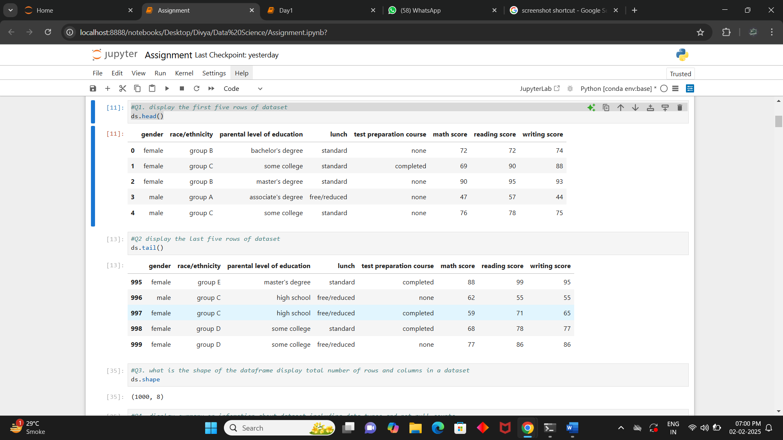

**Q.2. Display last 5 rows of dataset.**

**Ans:** ds.tail()



**Q.3. What is the shape of the dataset? ( total number of rows and columns in a dataset).**

**Ans:** ds.shape

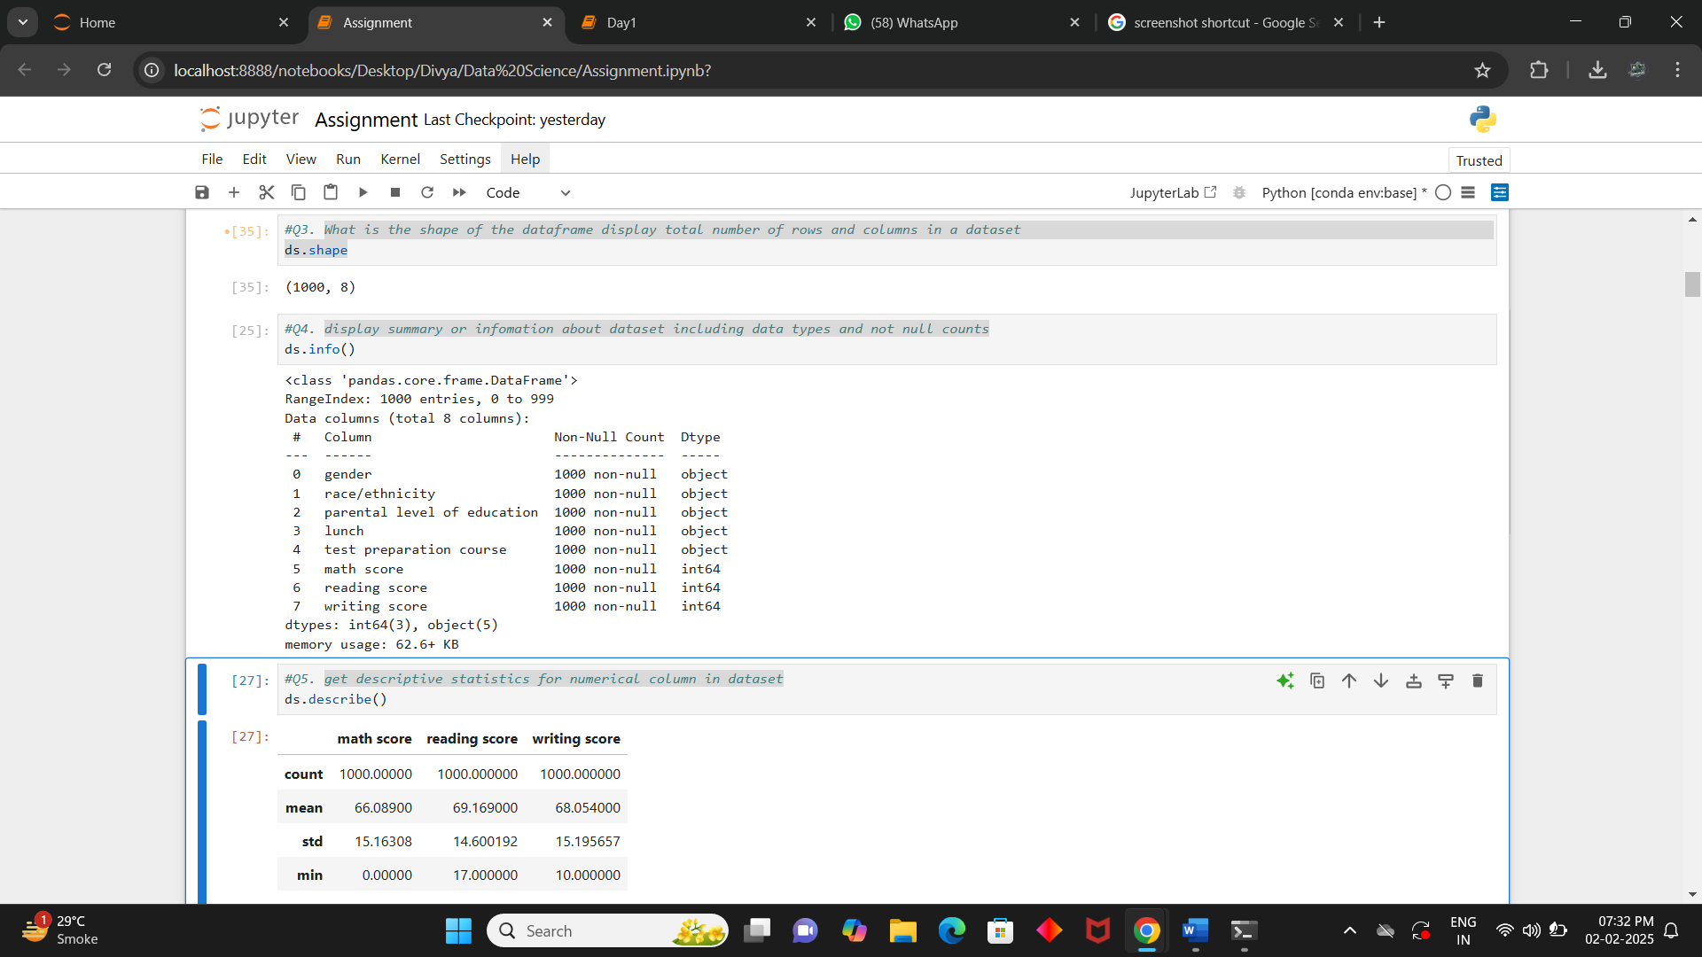

**Q.4. Display summary or information about dataset including data types and not null counts.**

**Ans:** ds.info()



**Q.5. Get descriptive statistics for numerical column in dataset.**

**Ans:** ds.describe()

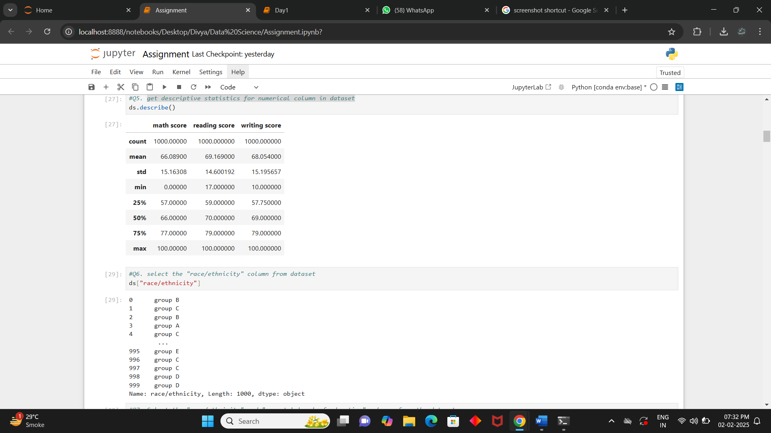

**Q.6. Select the "race/ethnicity" column from dataset**

**Ans:** ds["race/ethnicity"]



**Q.7. Select the "race/ethnicity" and "parental level of education" columns from the dataset**

**Ans:** ds[["race/ethnicity","parental level of education"]]

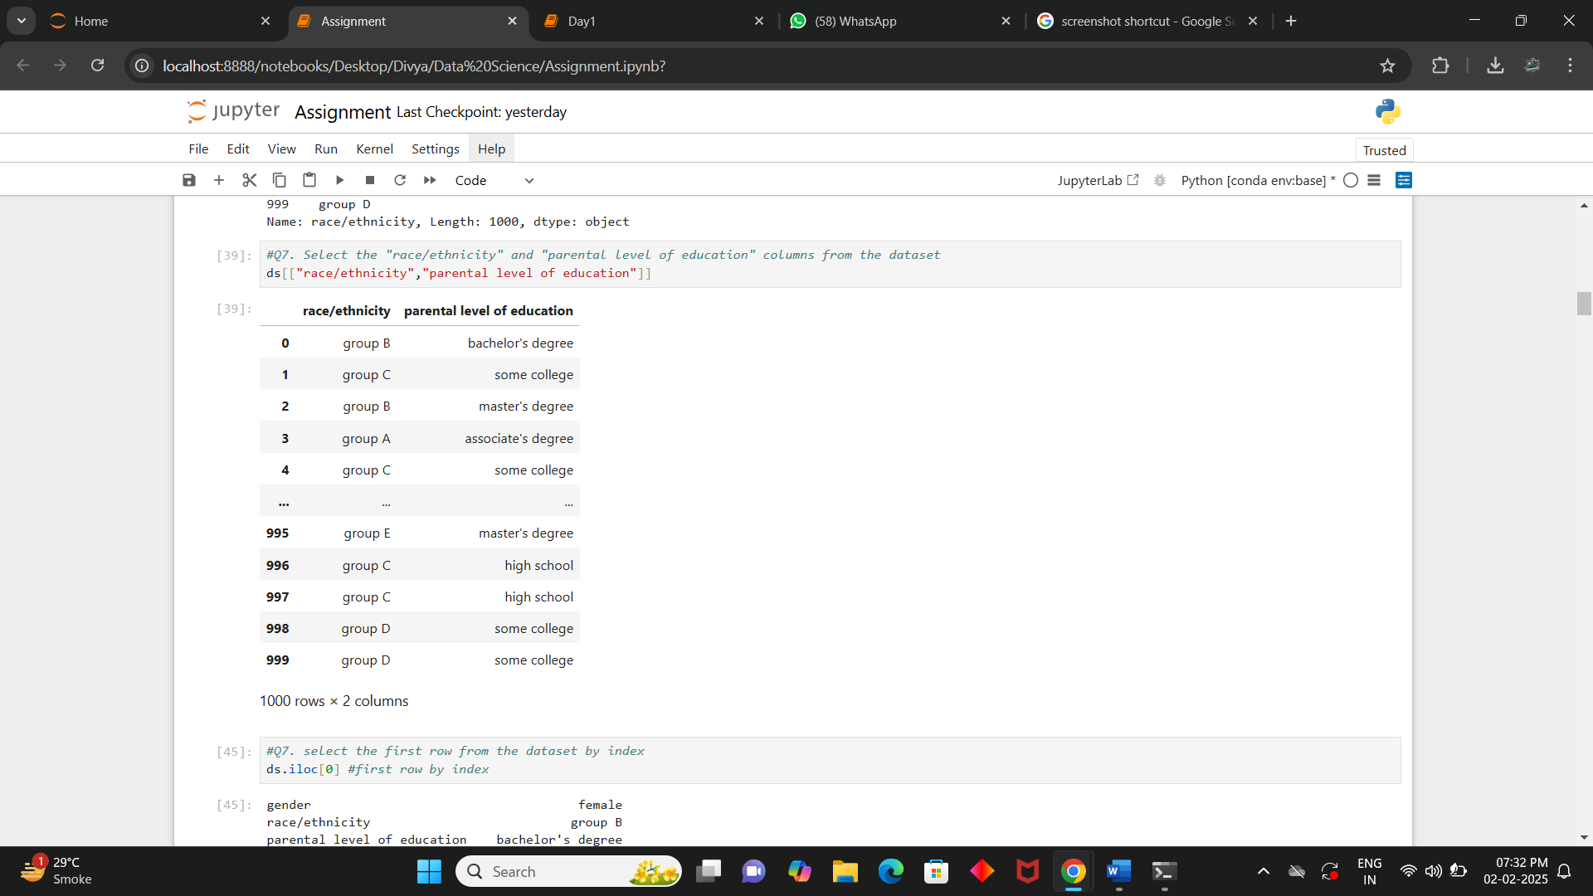

**Q.8. Select the first row from the dataset by index**

**Ans:** ds.iloc[0]

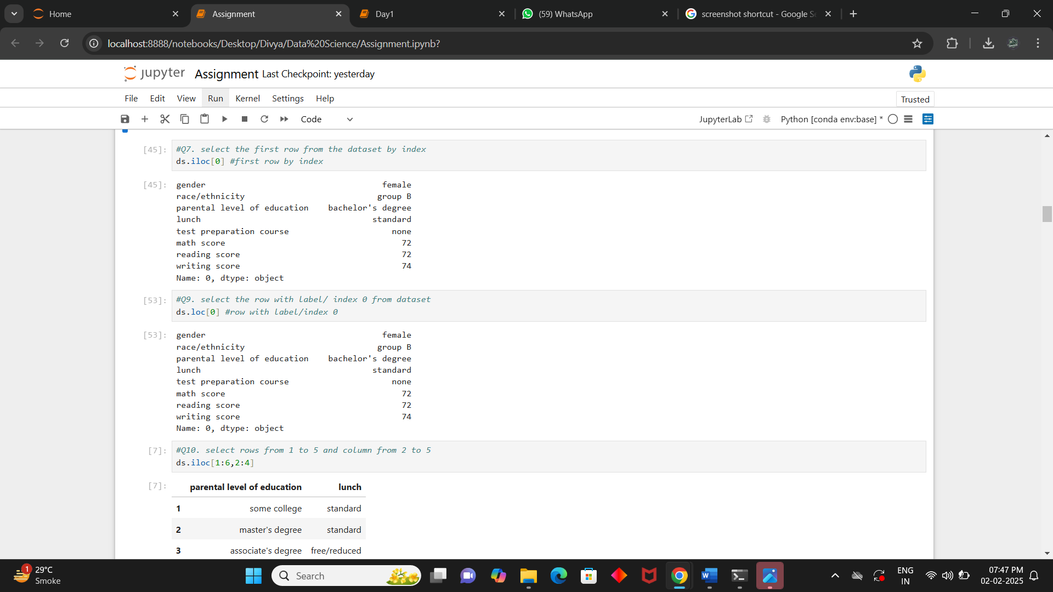

**Q.9. Select the row with label/ index 0 from dataset**

**Ans:** ds.loc[0]



**Q.10. Select rows from 1 to 5 and column from 2 to 5**

**Ans:** ds.iloc[1:6,2:4]

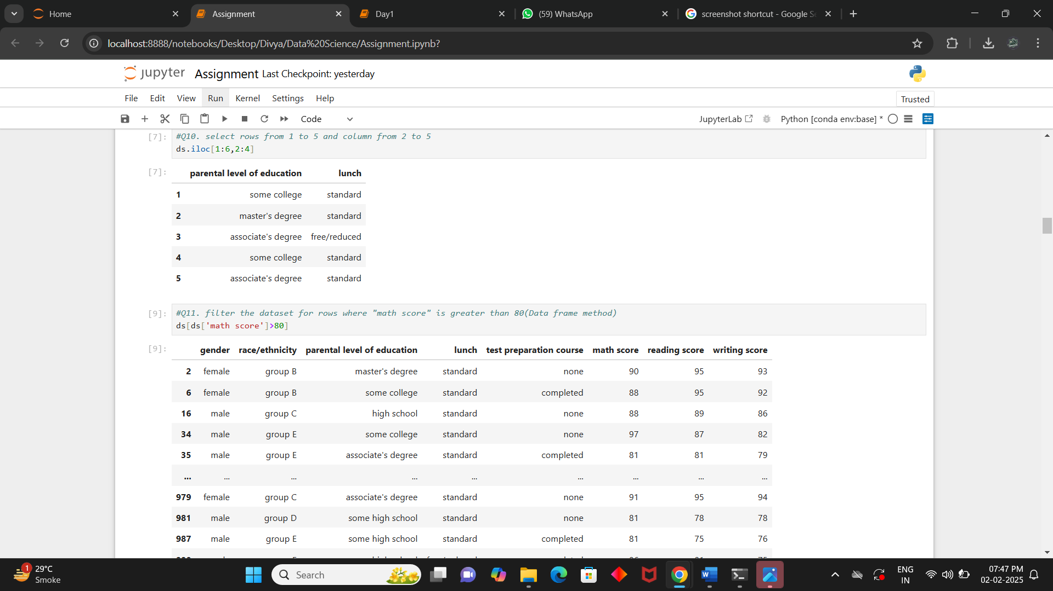

**Q.11. Filter the dataset for rows where "math score" is greater than 80(Data frame method)**

**Ans:** ds[ds['math score']>80]

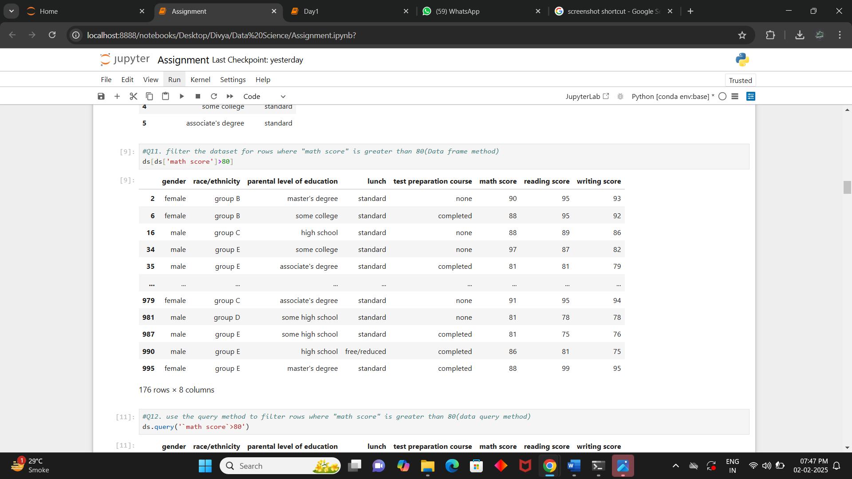

**Q.12. Use the query method to filter rows where "math score" is greater than 80(data query method)**

**Ans:** ds.query('`math score`>80')

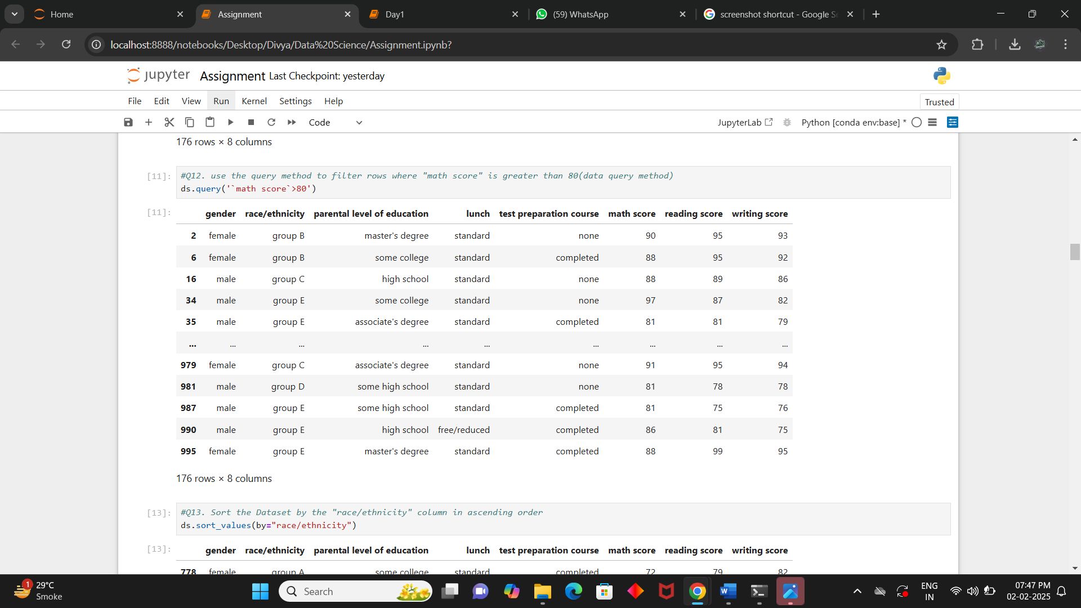

**Q.13. Sort the Dataset by the "race/ethnicity" column in ascending order**

**Ans:** ds.sort_values(by="race/ethnicity")

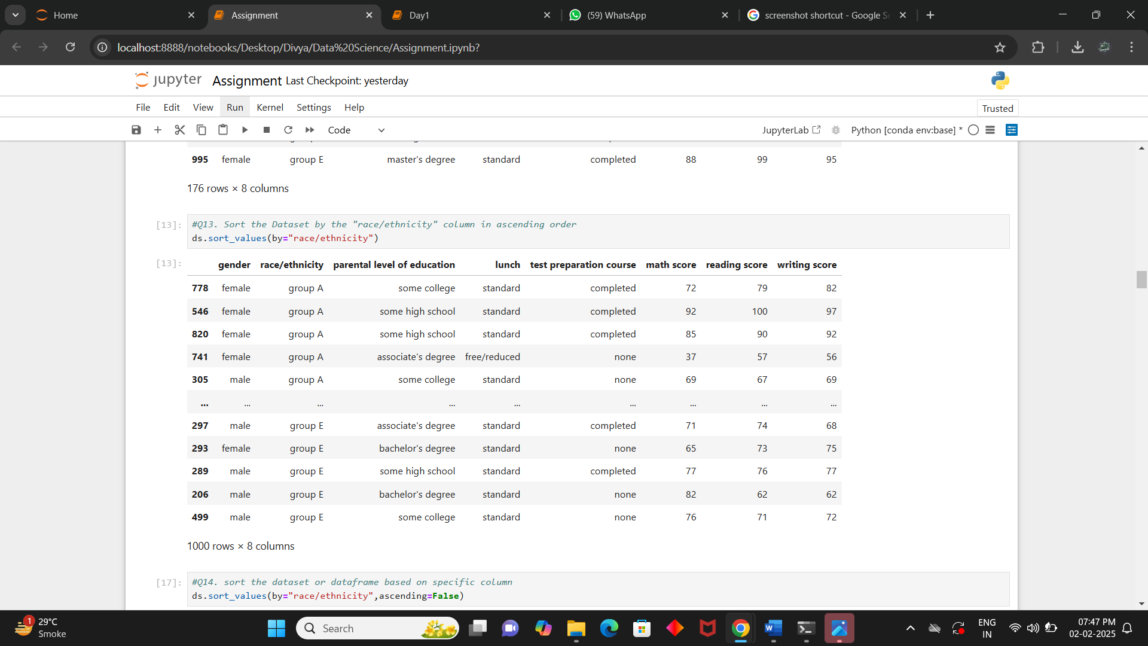

**Q.14. Sort the dataset or dataframe based on specific column**

**Ans:** ds.sort_values(by="race/ethnicity",ascending=False)

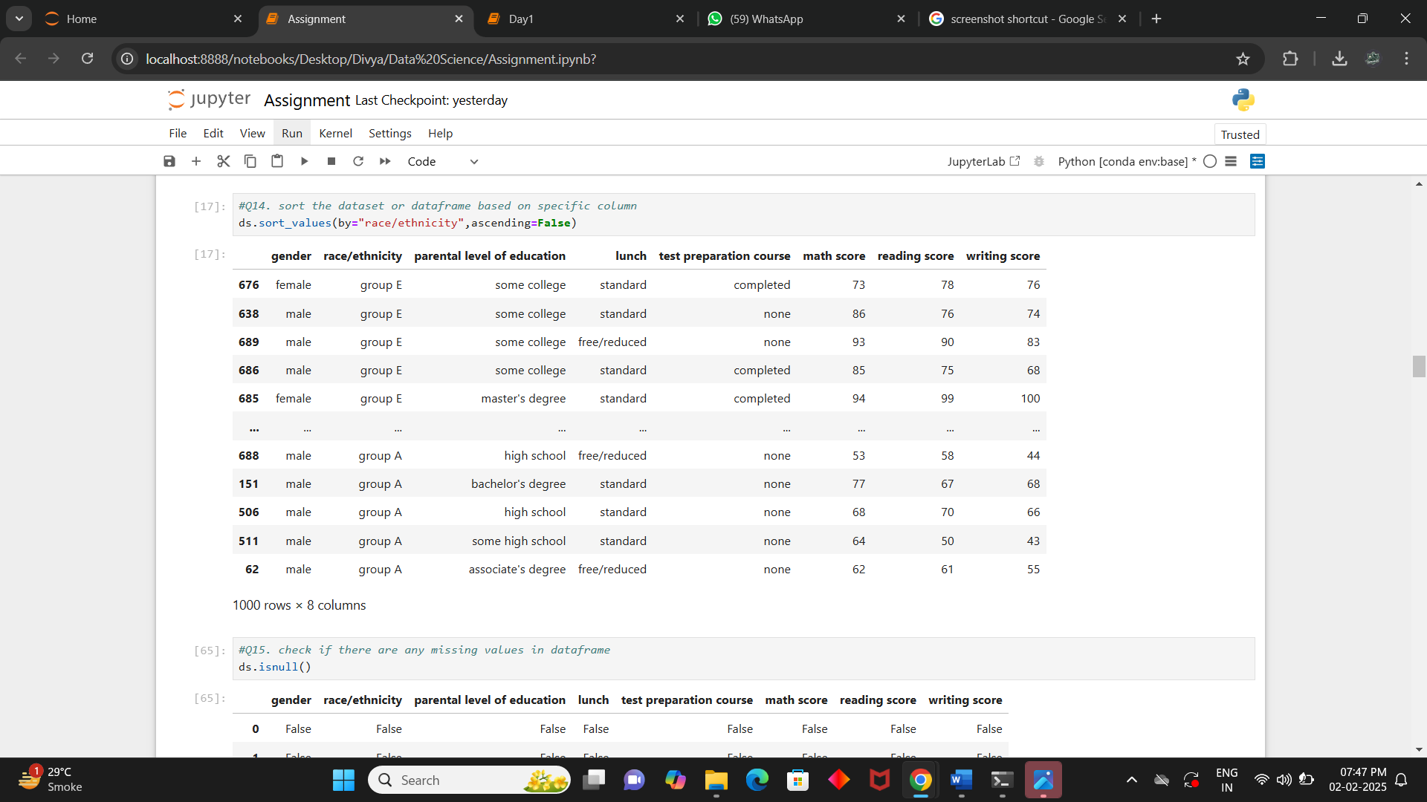

**Q.15. Check if there are any missing values in dataframe**

**Ans:** ds.isnull()

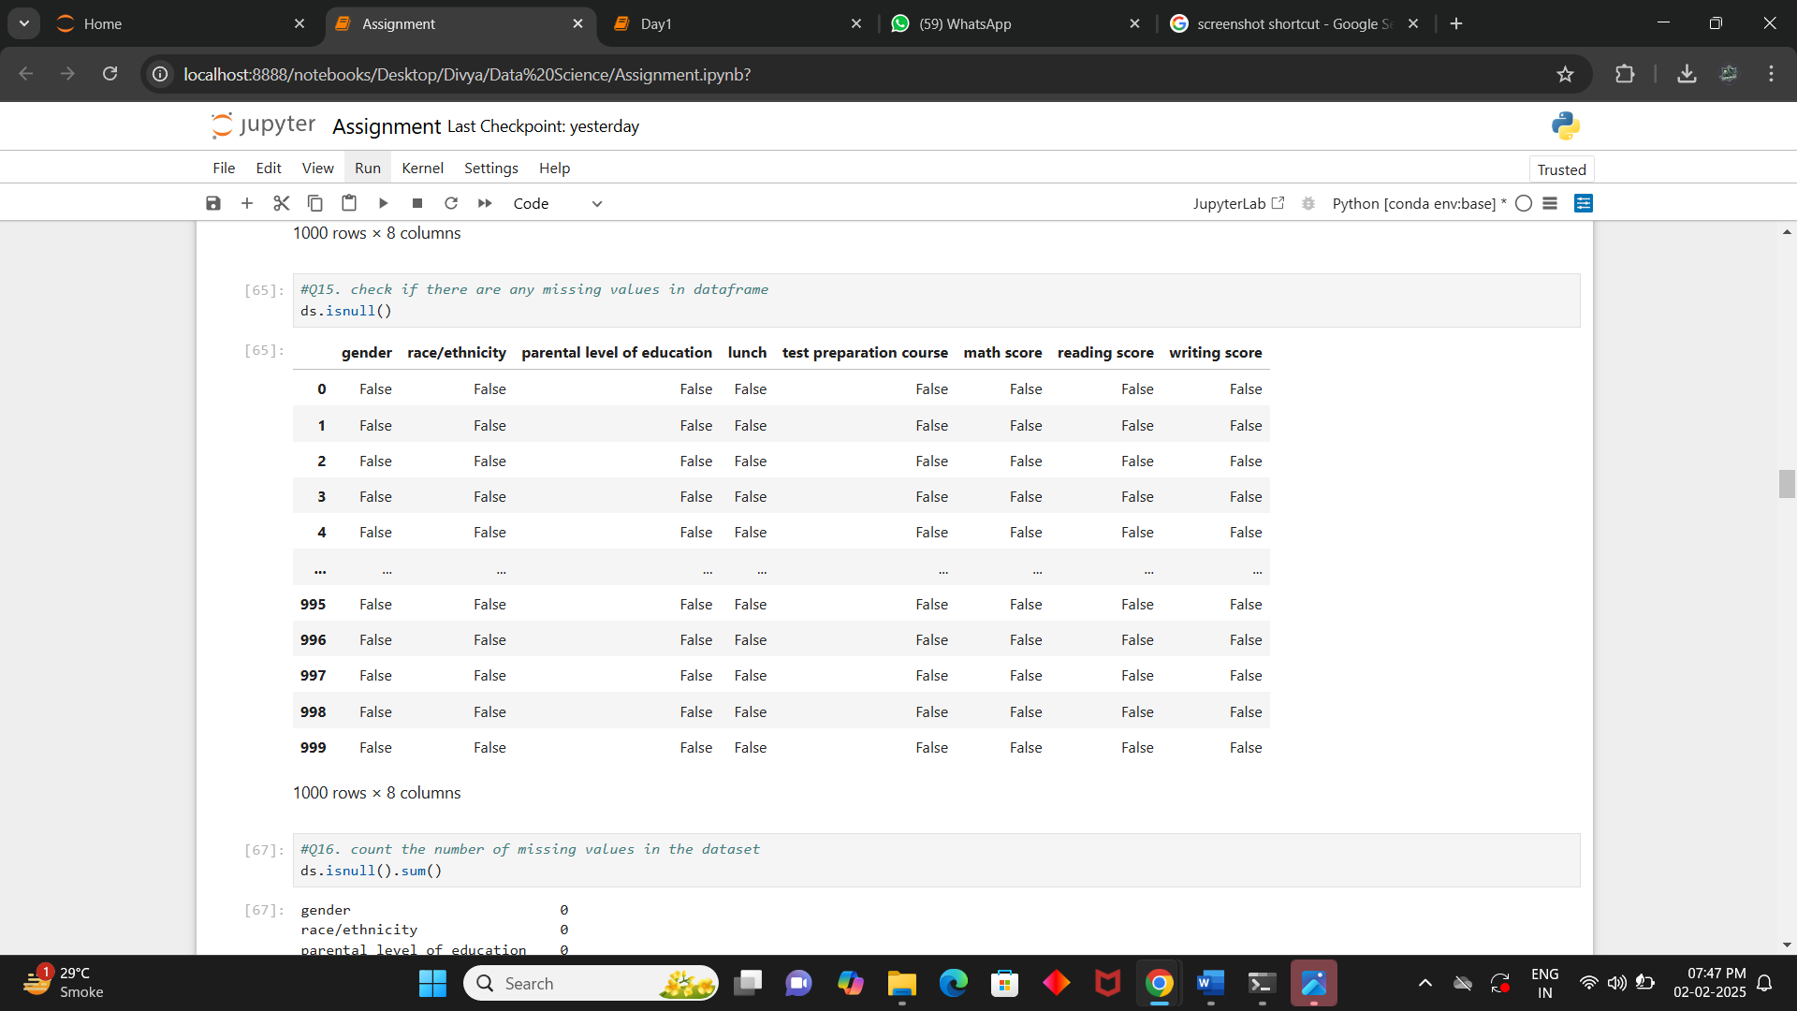

**Q.16. Count the number of missing values in the dataset**

**Ans:** ds.isnull().sum()

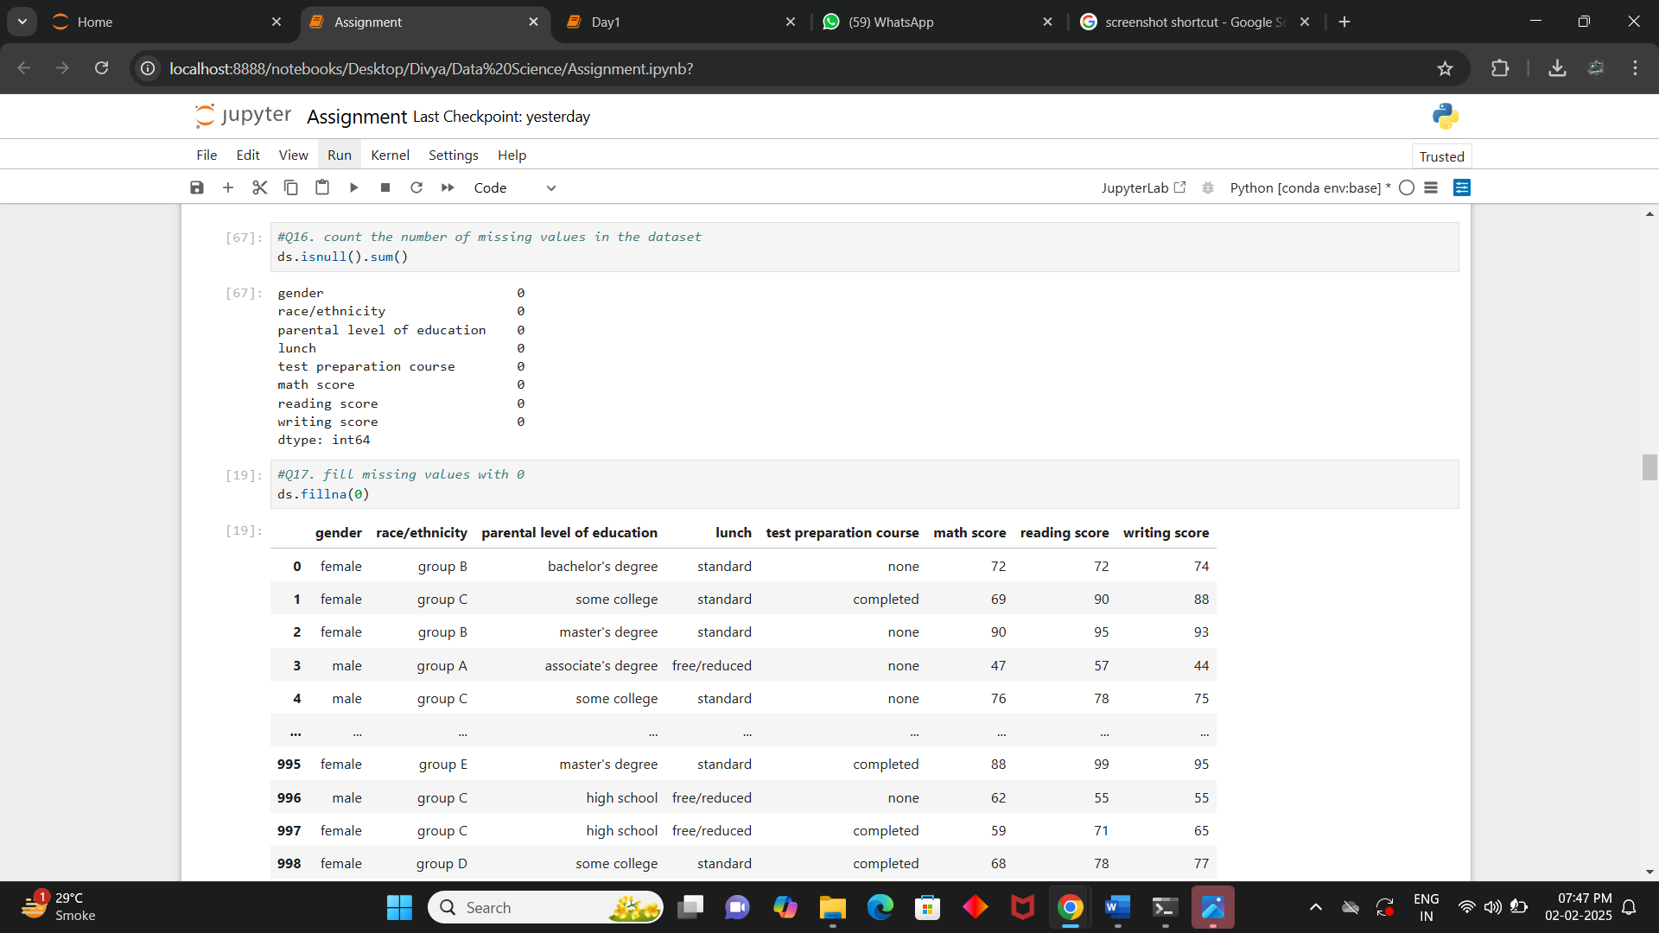

**Q.17. Fill missing values with 0**

**Ans:** ds.fillna(0,inplace=True)

ds.isnull().sum()

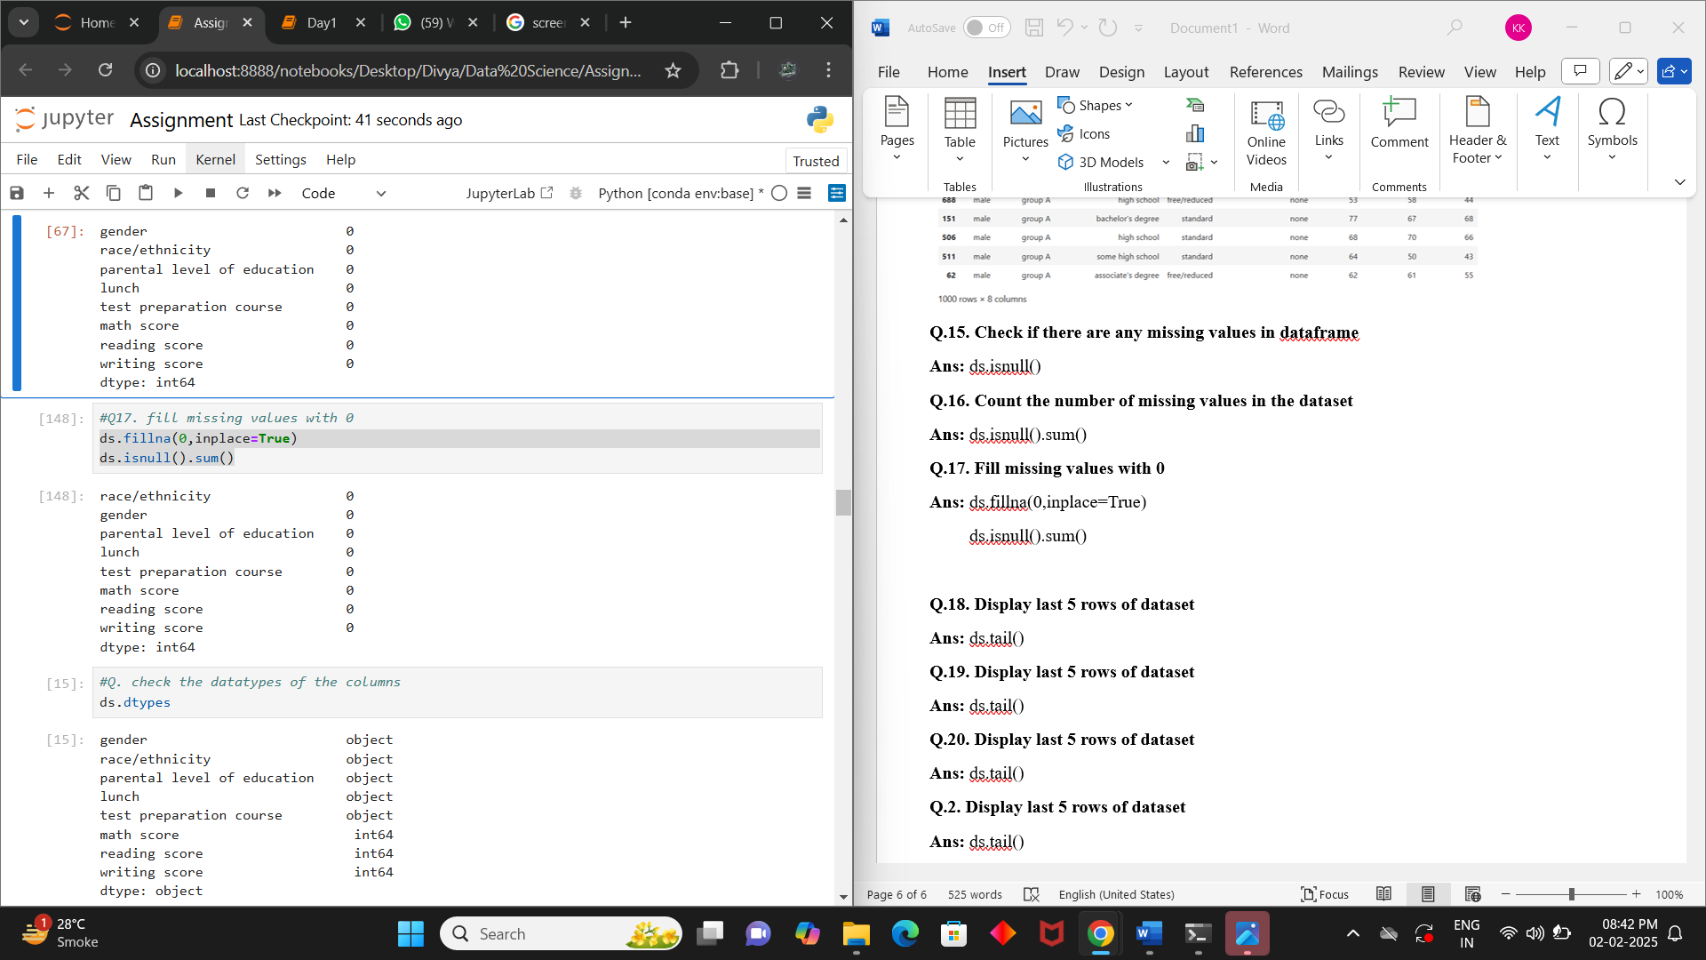

**Q.18. Check the datatypes of the columns**

**Ans:** ds.dtypes

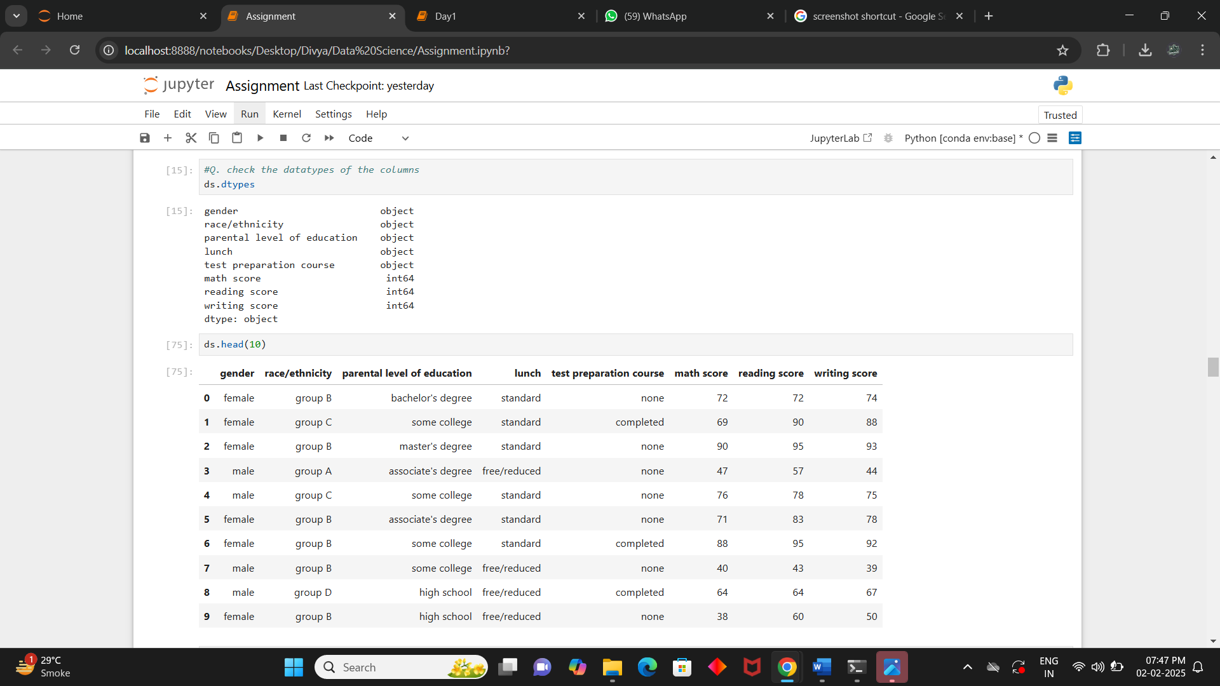

**Q.19. Filter the rows where the person's gender is male (data frame method)**

**Ans:** ds[ds["gender"]=="male"]

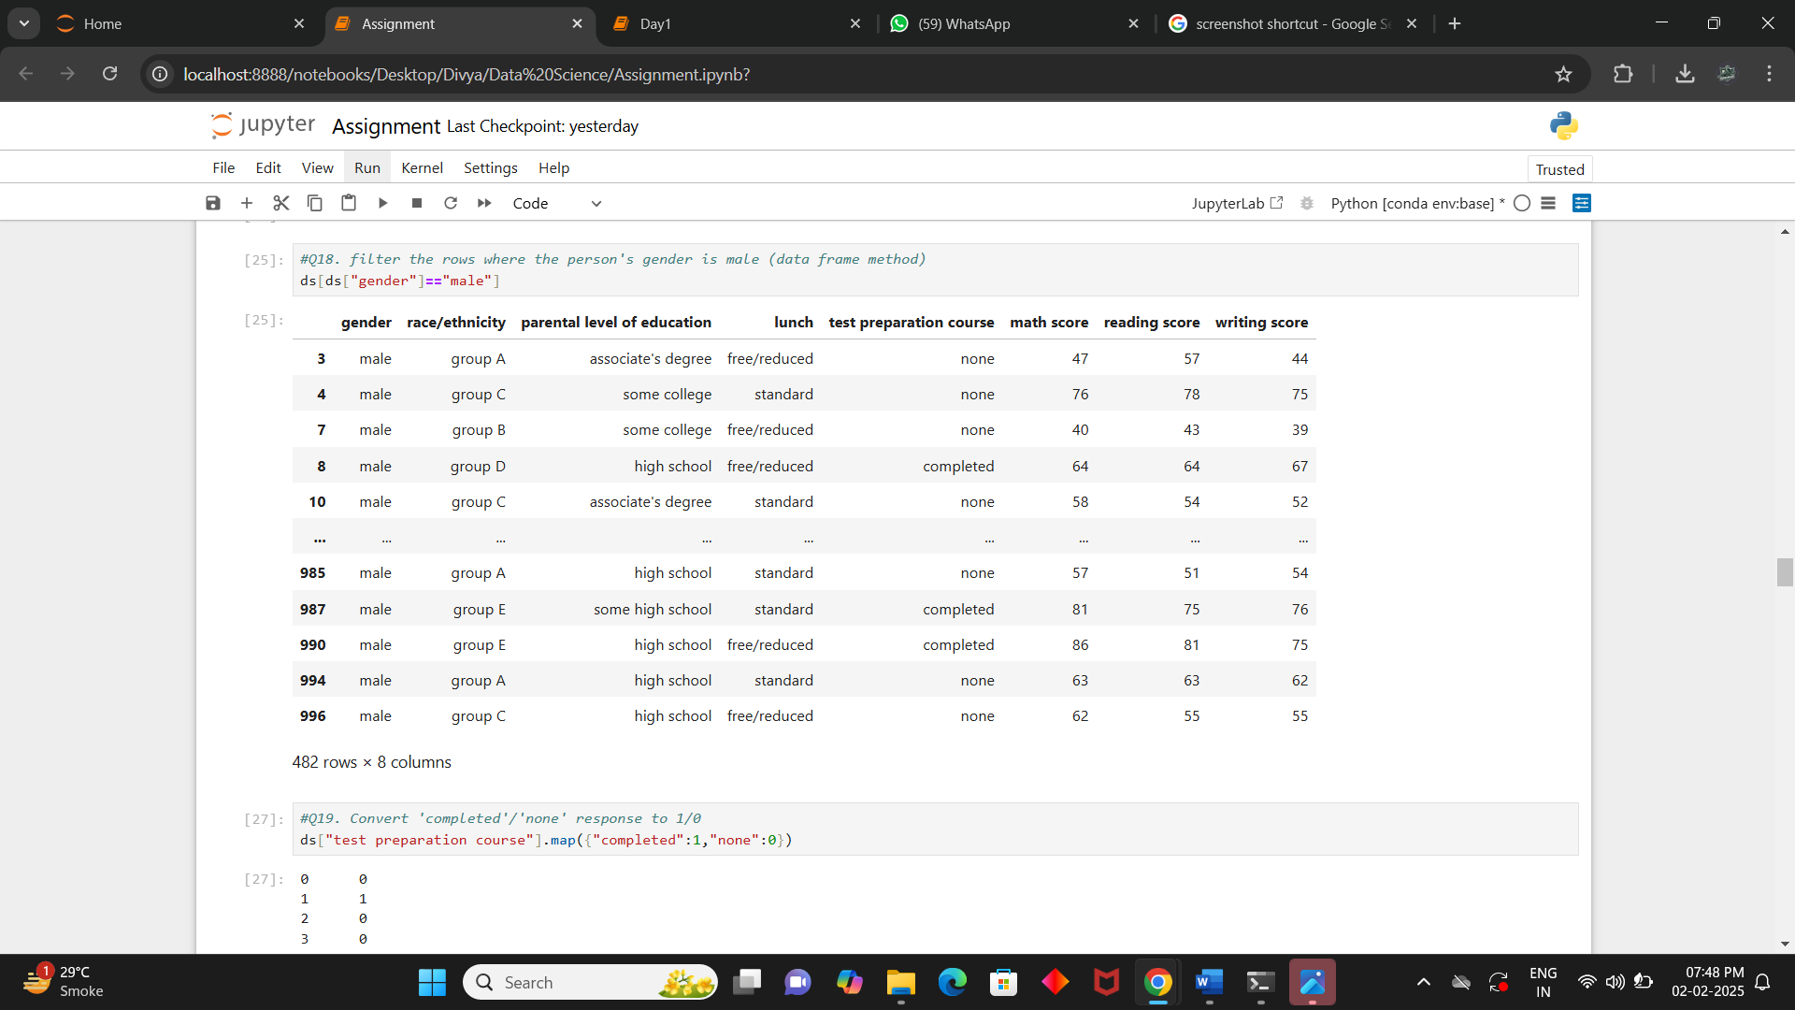

**Q.20. Convert completed/none response to 1/0**

**Ans:** ds["test preparation course"].map({"completed":1,"none":0})

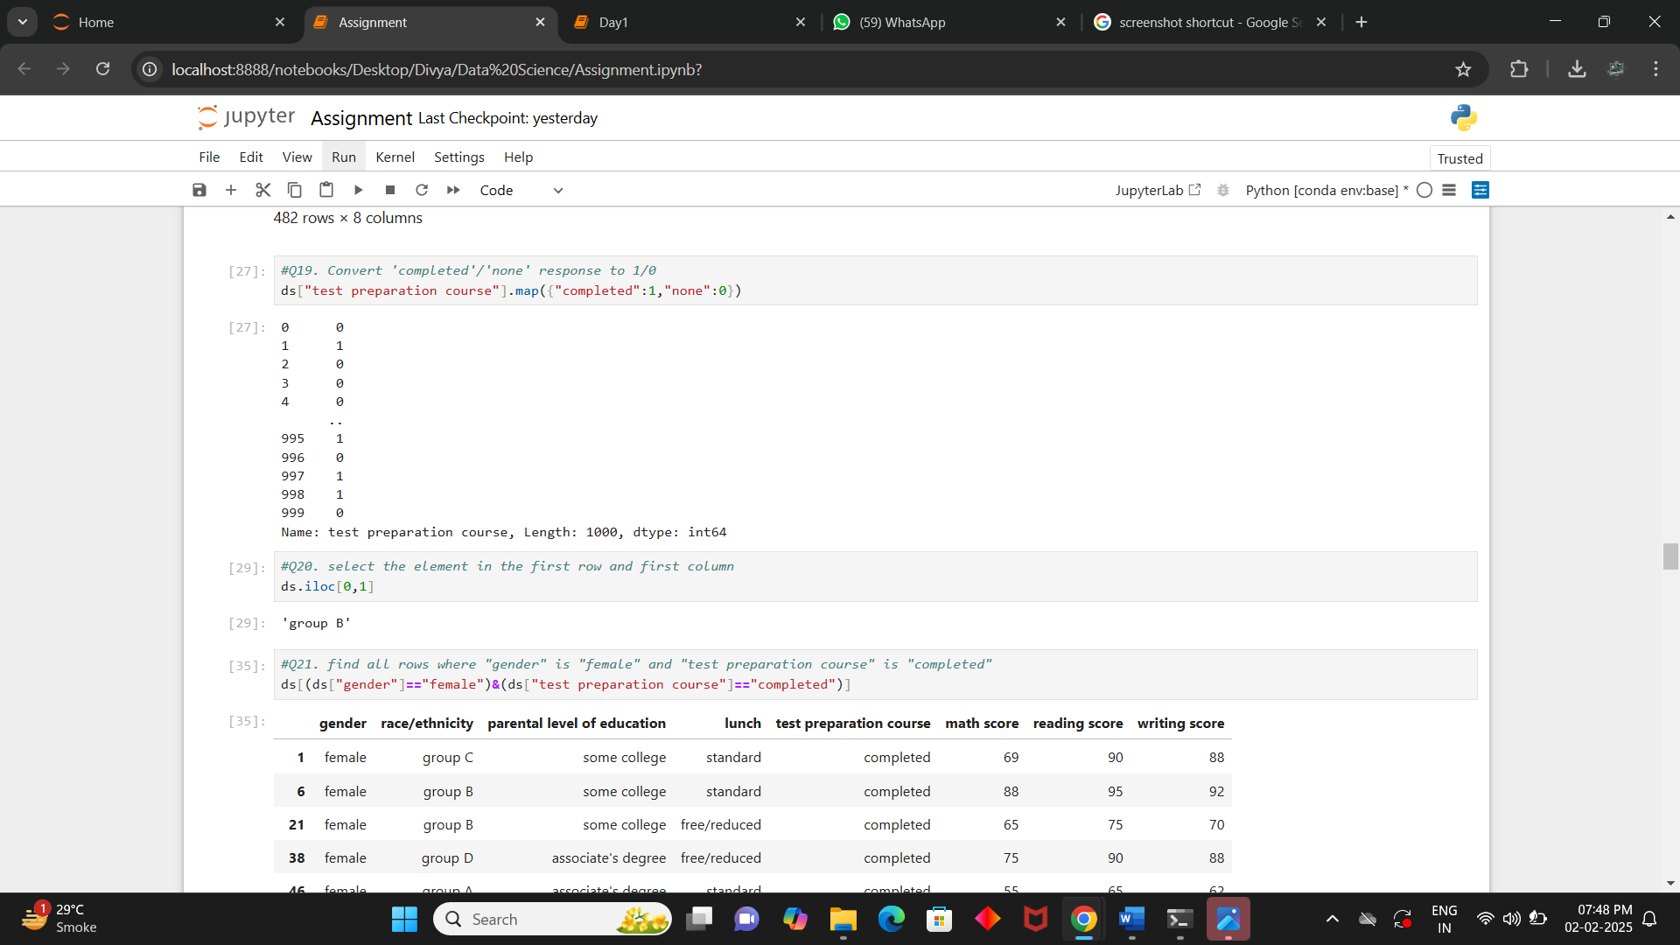

**Q.21. Select the element in the first row and first column**

**Ans:** ds.iloc[0,0]

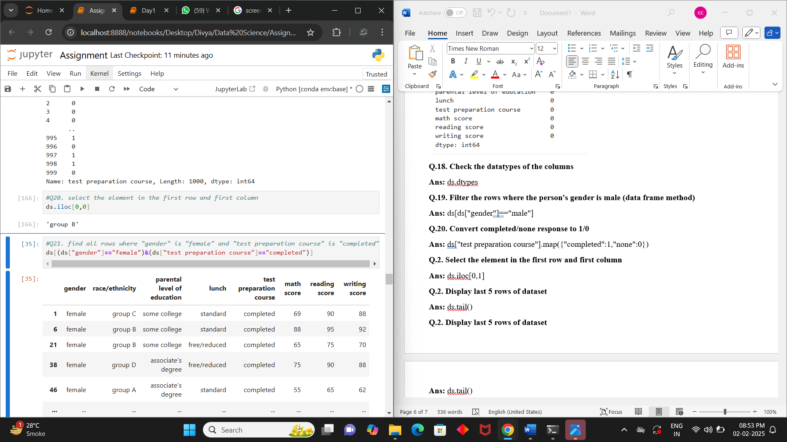

**Q.22. find all rows where "gender" is "female" and "test preparation course" is "completed"**

**Ans:** ds[(ds["gender"]=="female")&(ds["test preparation course"]=="completed")]

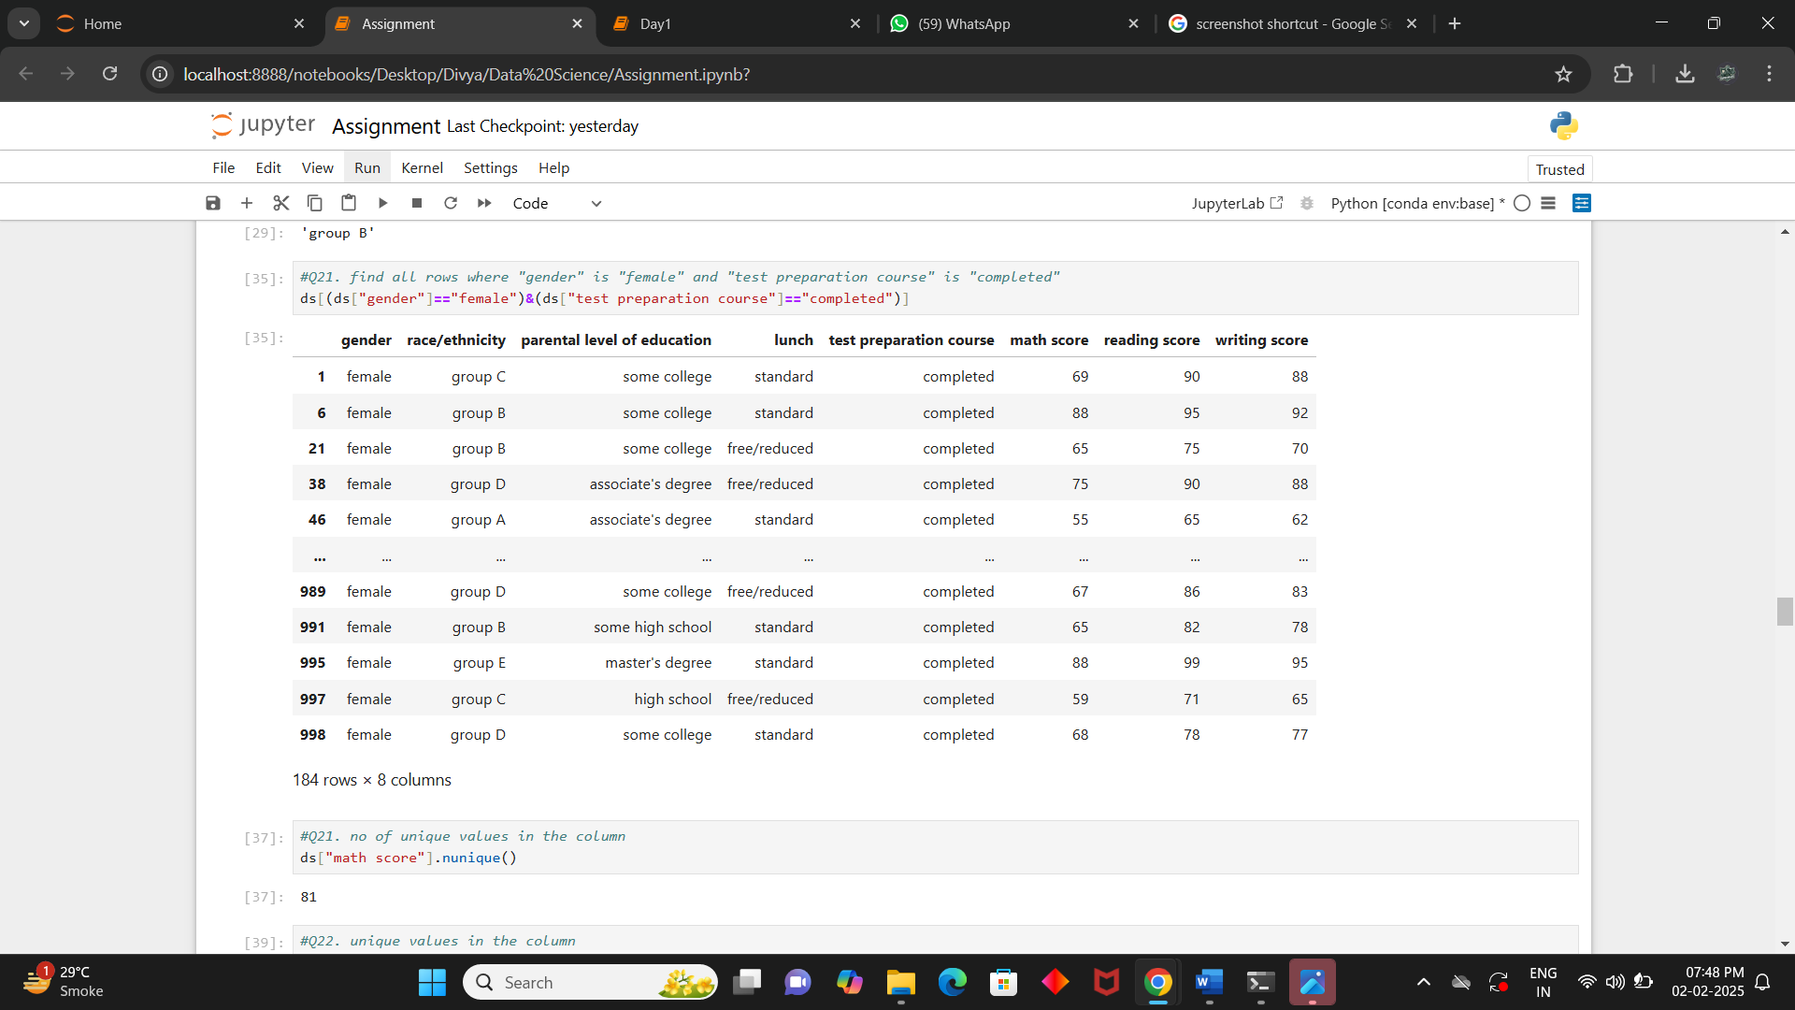

**Q.23. Find unique values in the column “math score”**

**Ans:** ds["math score"].unique()

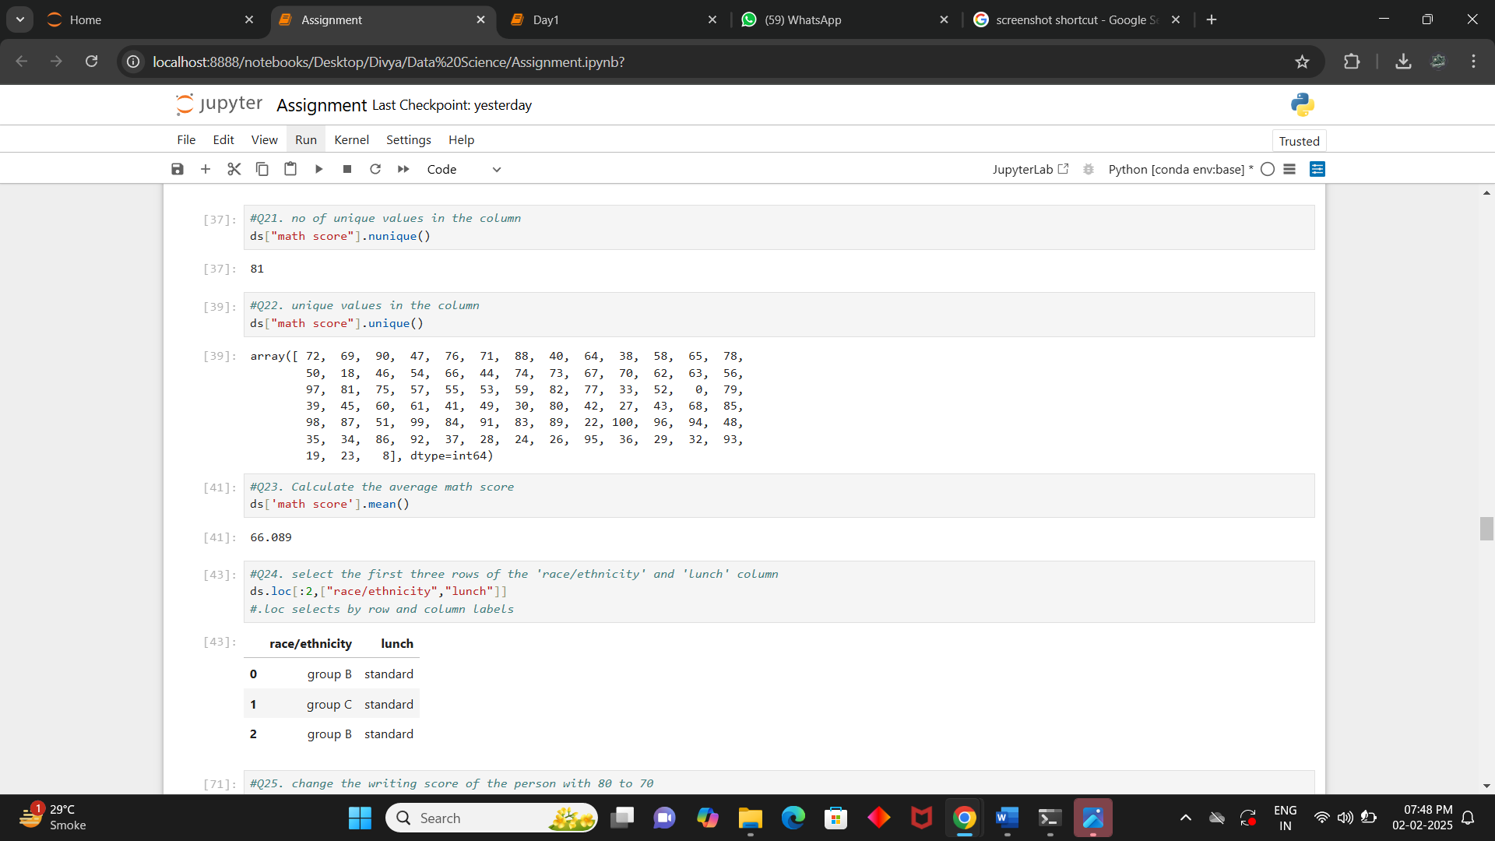

**Q.24. Find number of unique values in the column**

**Ans:** ds["math score"].nunique()



**Q.25. Calculate the average math score**

**Ans:** ds['math score'].mean()

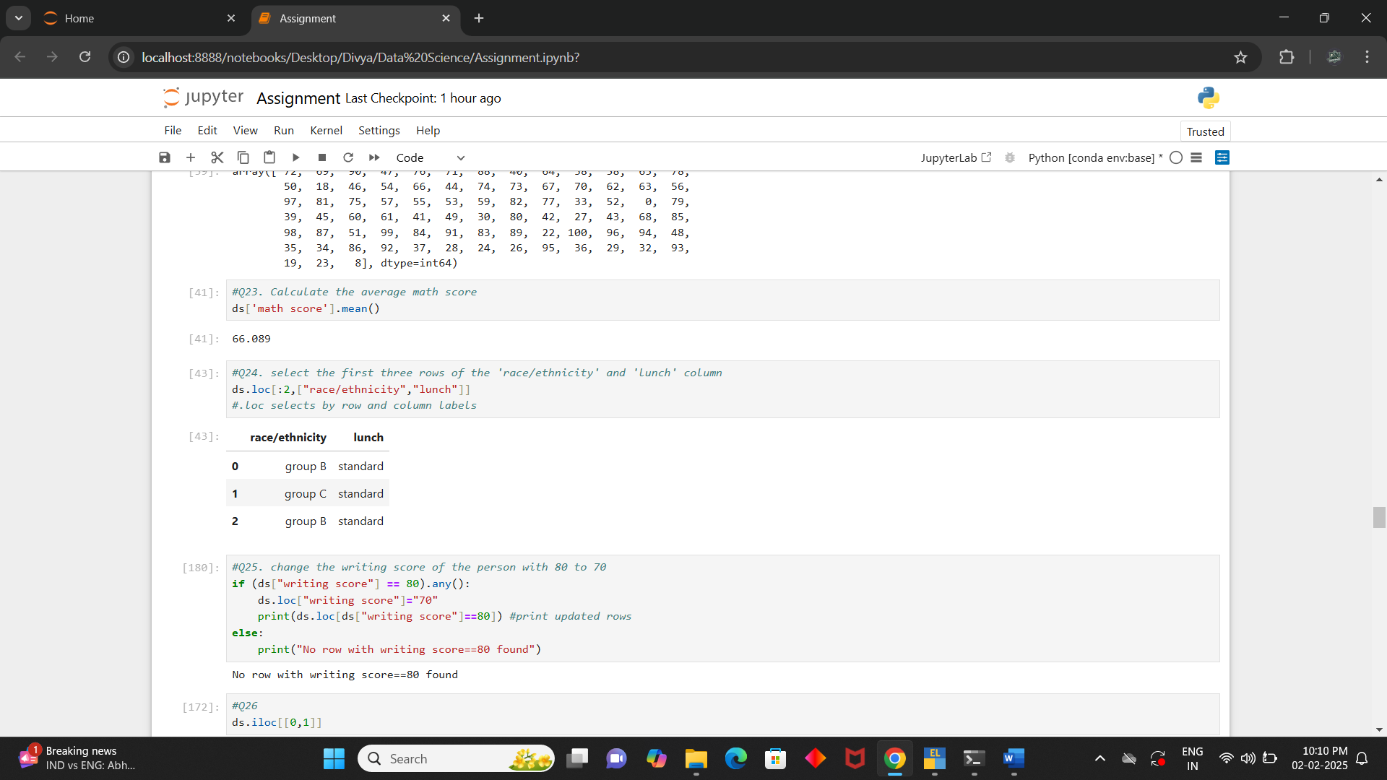

**Q.26. Select the first three rows of the 'race/ethnicity' and 'lunch' column**

**Ans:** ds.loc[:2,["race/ethnicity","lunch"]]



**Q.27. Change the writing score of the person with 80 to 70**

**Ans:** if (ds["writing score"] == 80).any():

ds.loc["writing score"]="70"

print(ds.loc[ds["writing score"]==80]) #print updated rows

else:

print("No row with writing score==80 found")

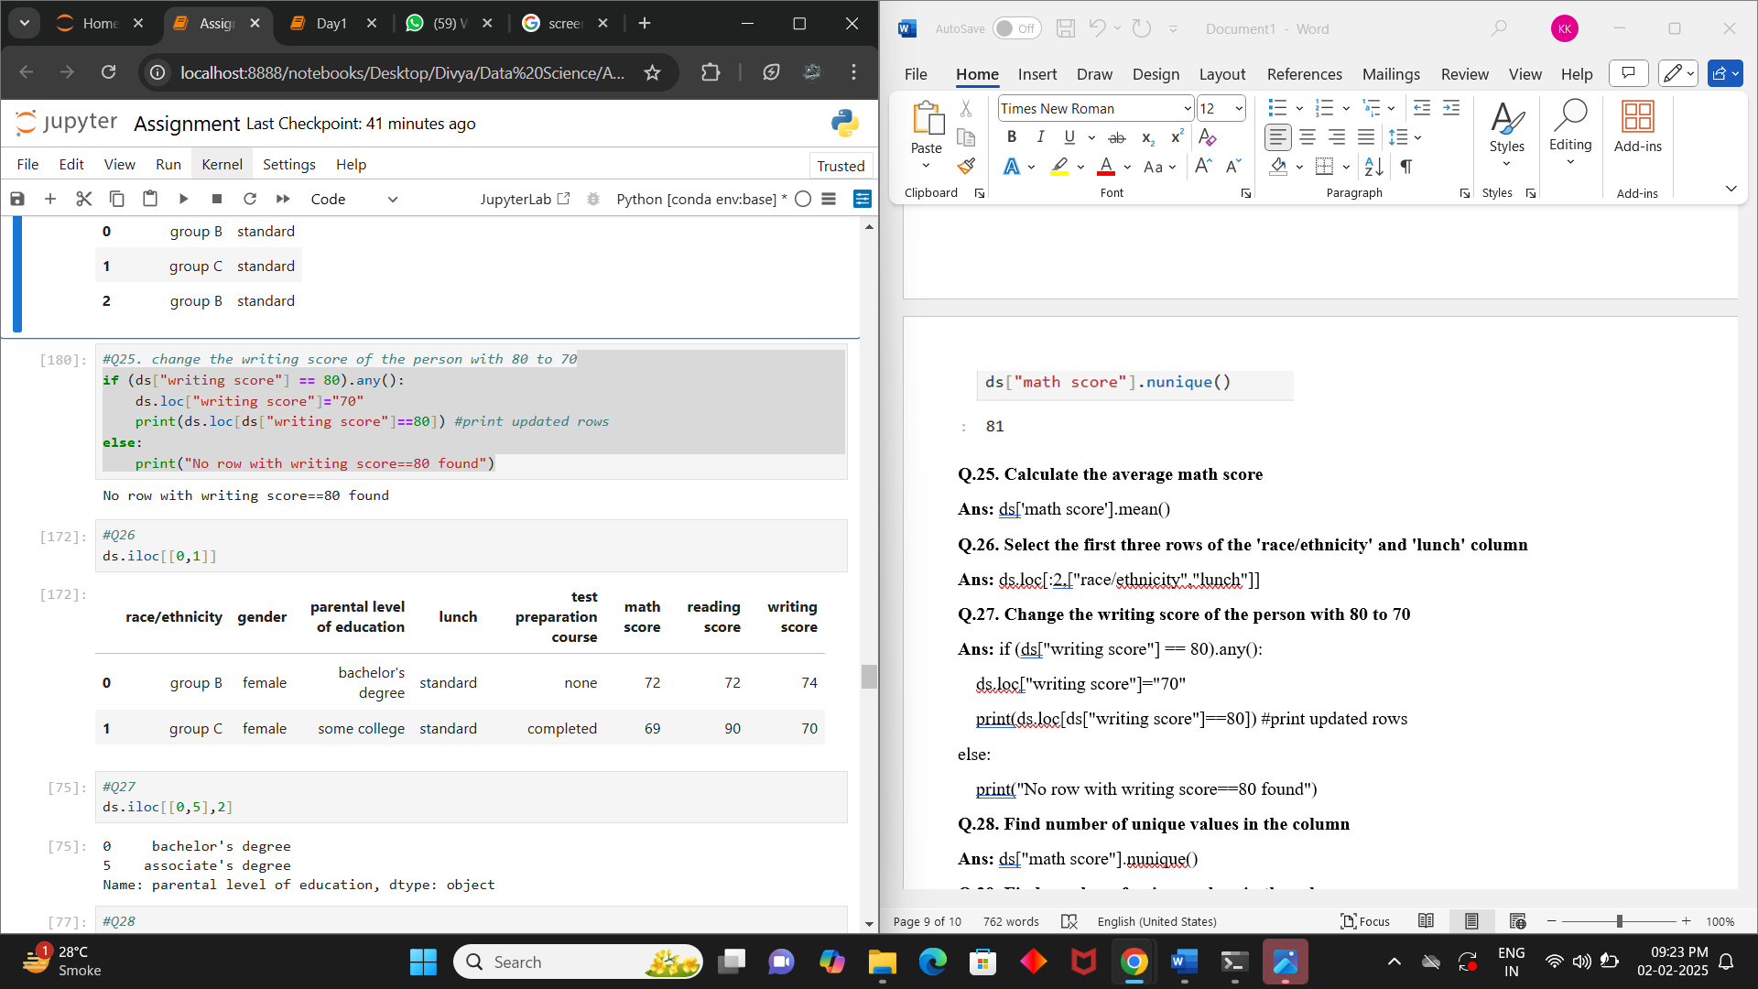

**Q.28. Find number of unique values in the column**

**Ans:** ds.iloc[[0,1]]



**Q.29.**

**Ans:** ds.iloc[[0,5],2]



**Q.30.**

**Ans:** ds.loc[[0,5],["race/ethnicity","math score"]]

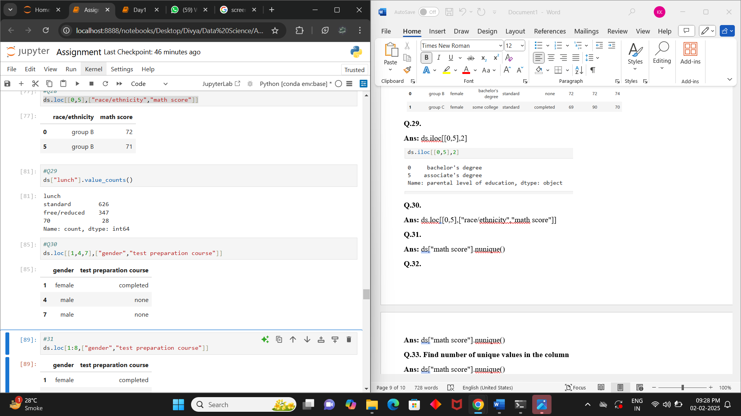

**Q.31.**

**Ans:** ds["lunch"].value_counts()



**Q.32.**

**Ans:** ds.loc[[1,4,7],["gender","test preparation course"]]



**Q.33.**

**Ans:** ds.loc[1:8,["gender","test preparation course"]]

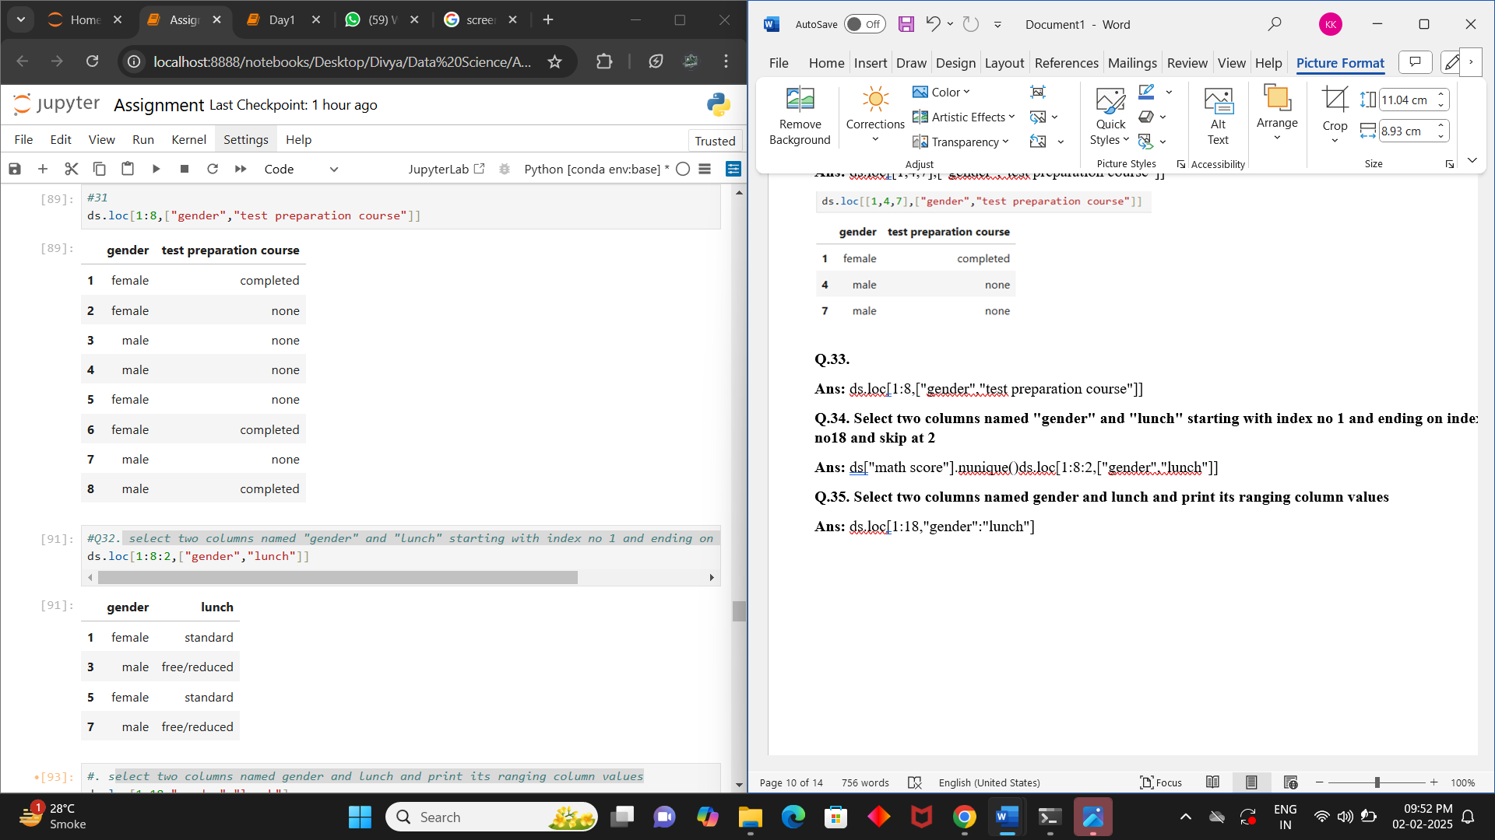

**Q.34. Select two columns named "gender" and "lunch" starting with index no 1 and ending on index no18 and skip at 2**

**Ans:** ds["math score"].nunique()ds.loc[1:8:2,["gender","lunch"]]



**Q.35. Select two columns named gender and lunch and print its ranging column values**

**Ans:** ds.loc[1:18,"gender":"lunch"]

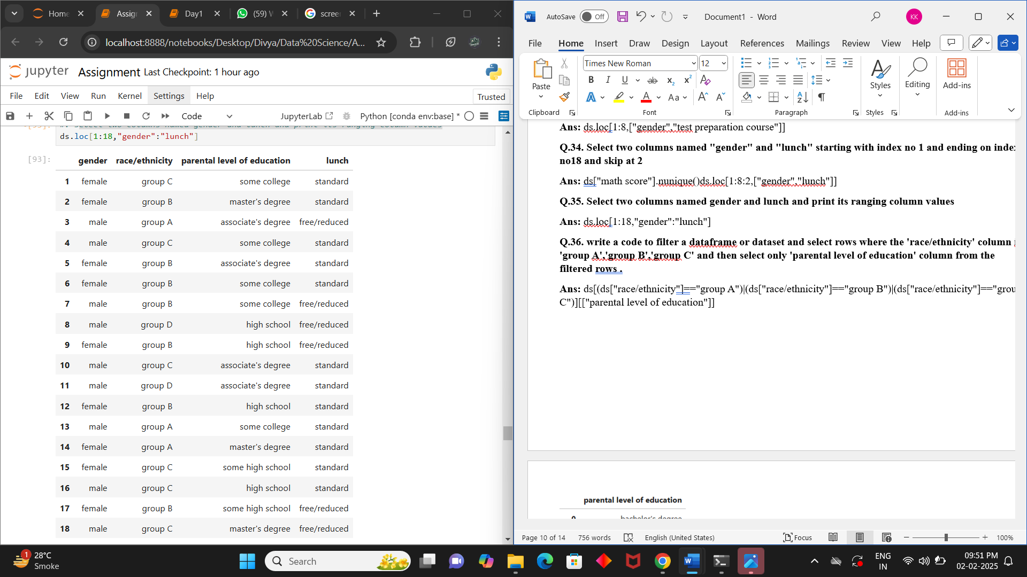

**Q.36. write a code to filter a dataframe or dataset and select rows where the 'race/ethnicity' column iis 'group A','group B','group C' and then select only 'parental level of education' column from the filtered rows .**

**Ans:** ds[(ds["race/ethnicity"]=="group A")|(ds["race/ethnicity"]=="group B")|(ds["race/ethnicity"]=="group C")][["parental level of education"]]

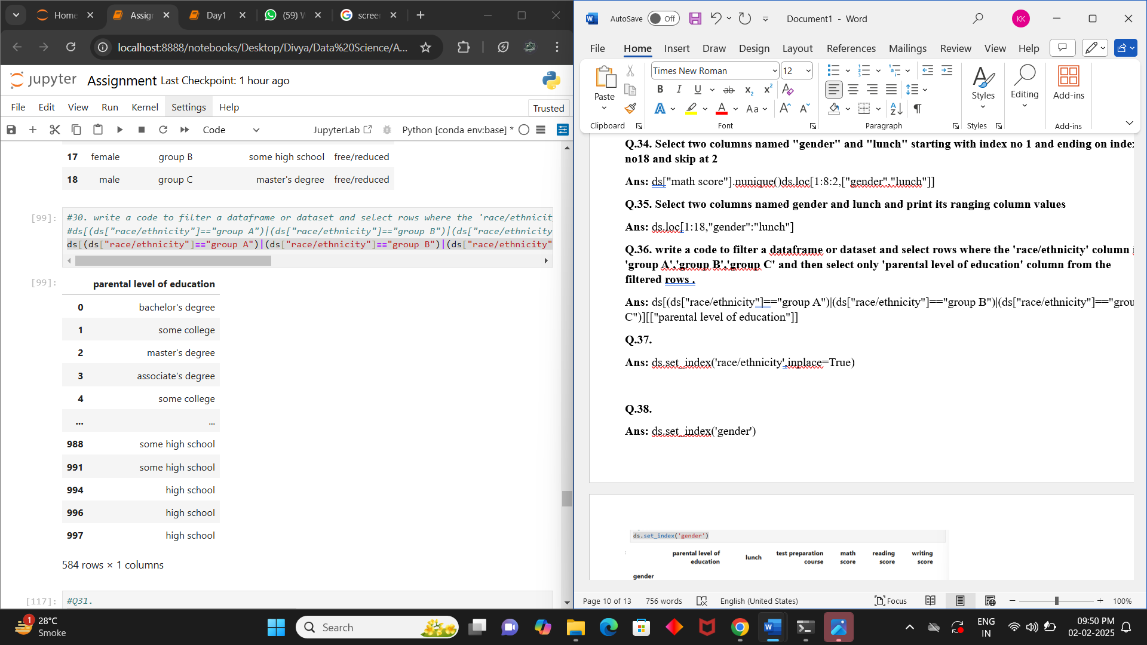

**Q.38.**

**Ans:** ds.set_index('gender')

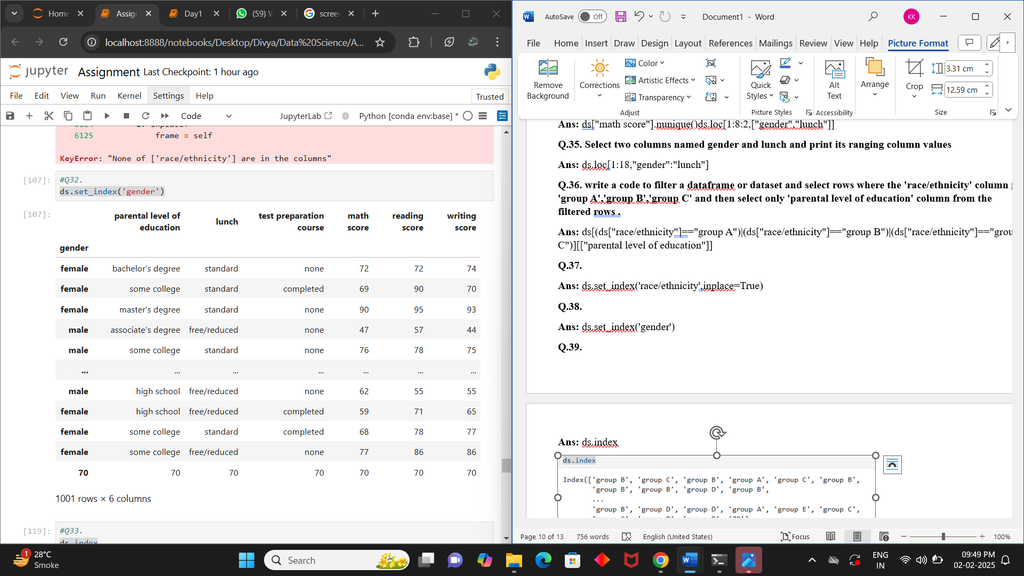

**Q.39.**

**Ans:** ds.index

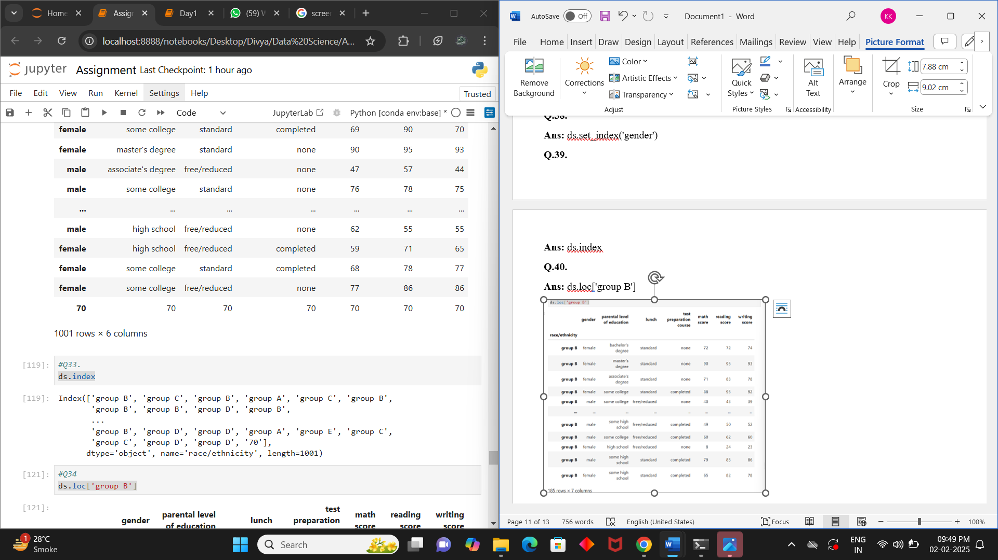

**Q.40.**

**Ans:** ds.loc['group B']

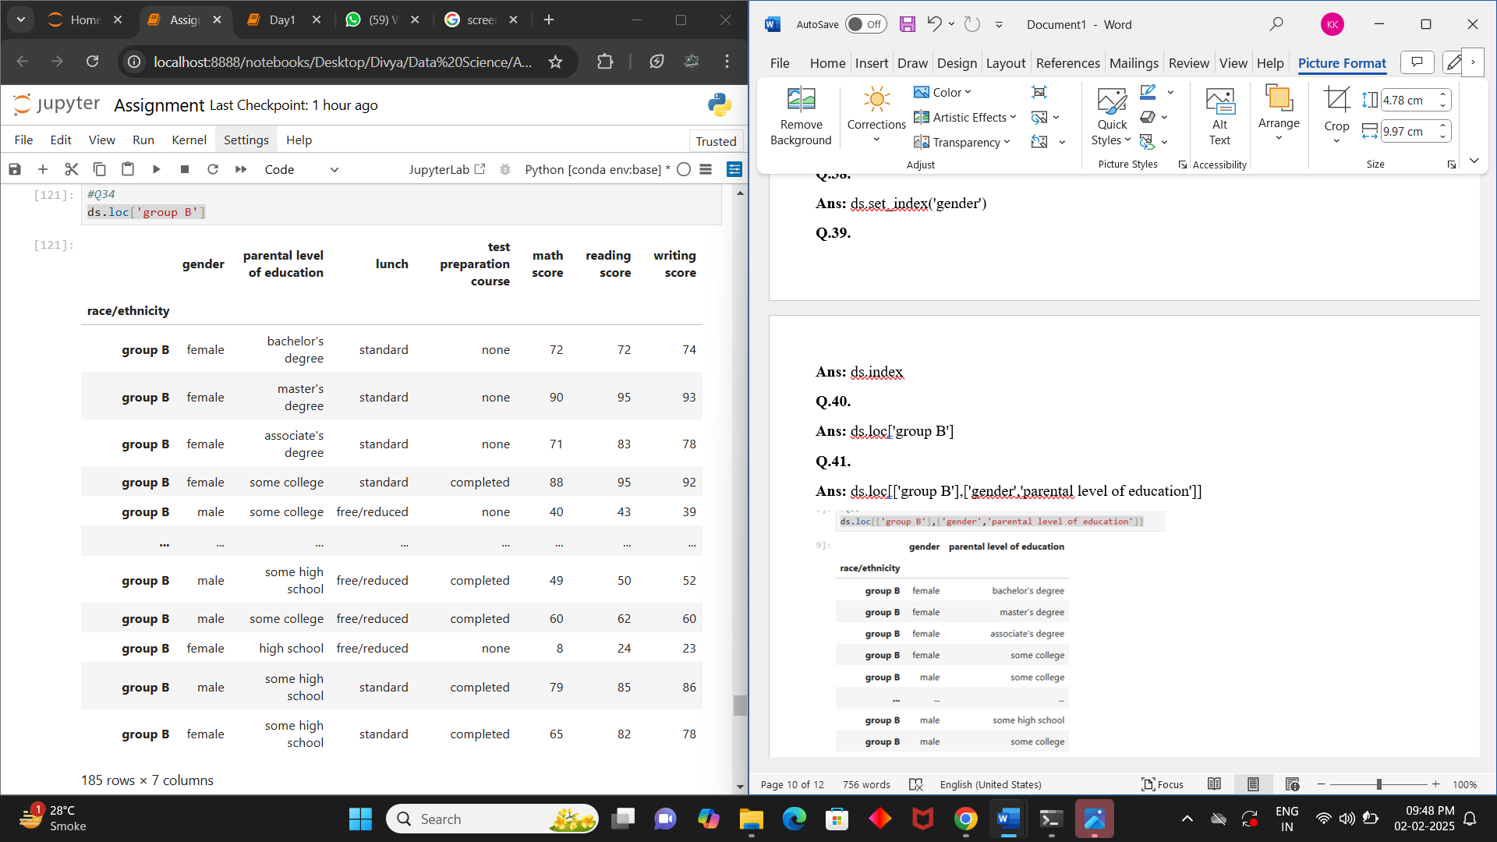

**Q.41.**

**Ans:** ds.loc[['group B'],['gender','parental level of education']]

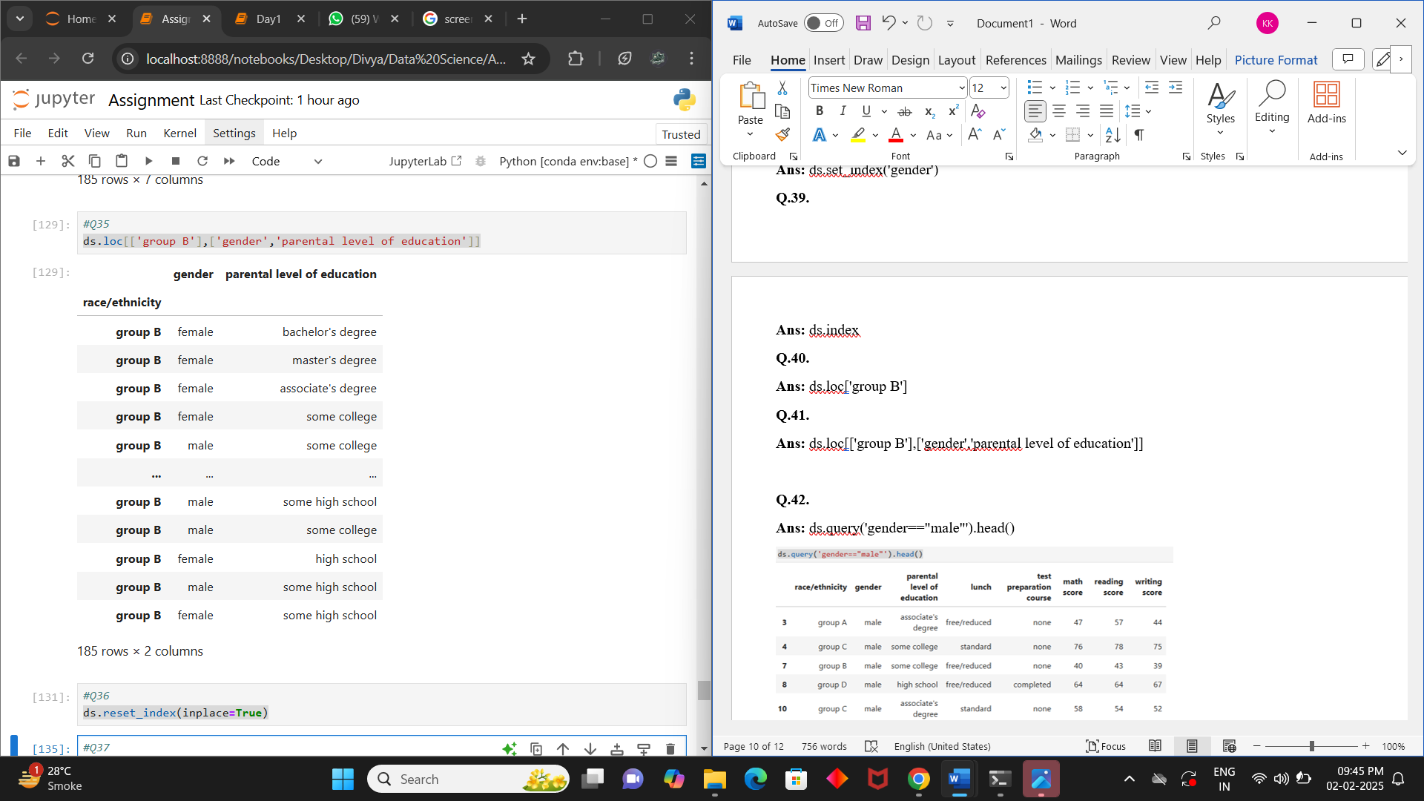

**Q.42.**

**Ans:** ds.query('gender=="male"').head()

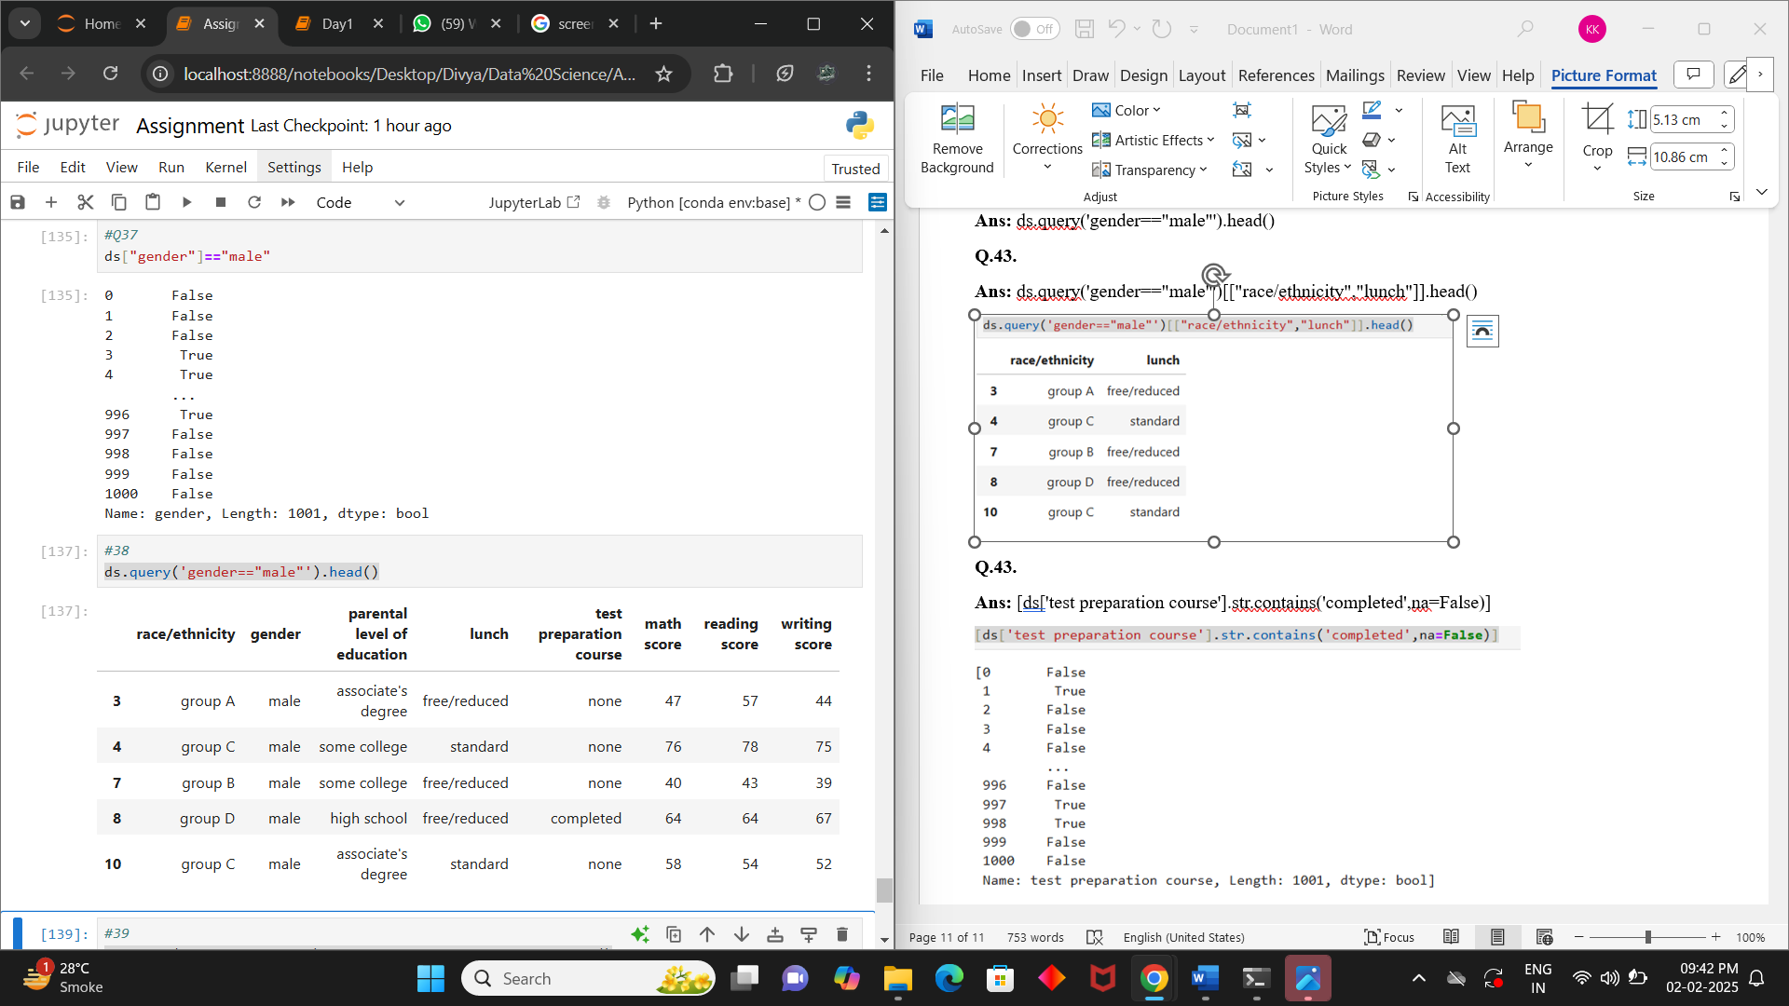

**Q.43.**

**Ans:** ds.query('gender=="male"')[["race/ethnicity","lunch"]].head()

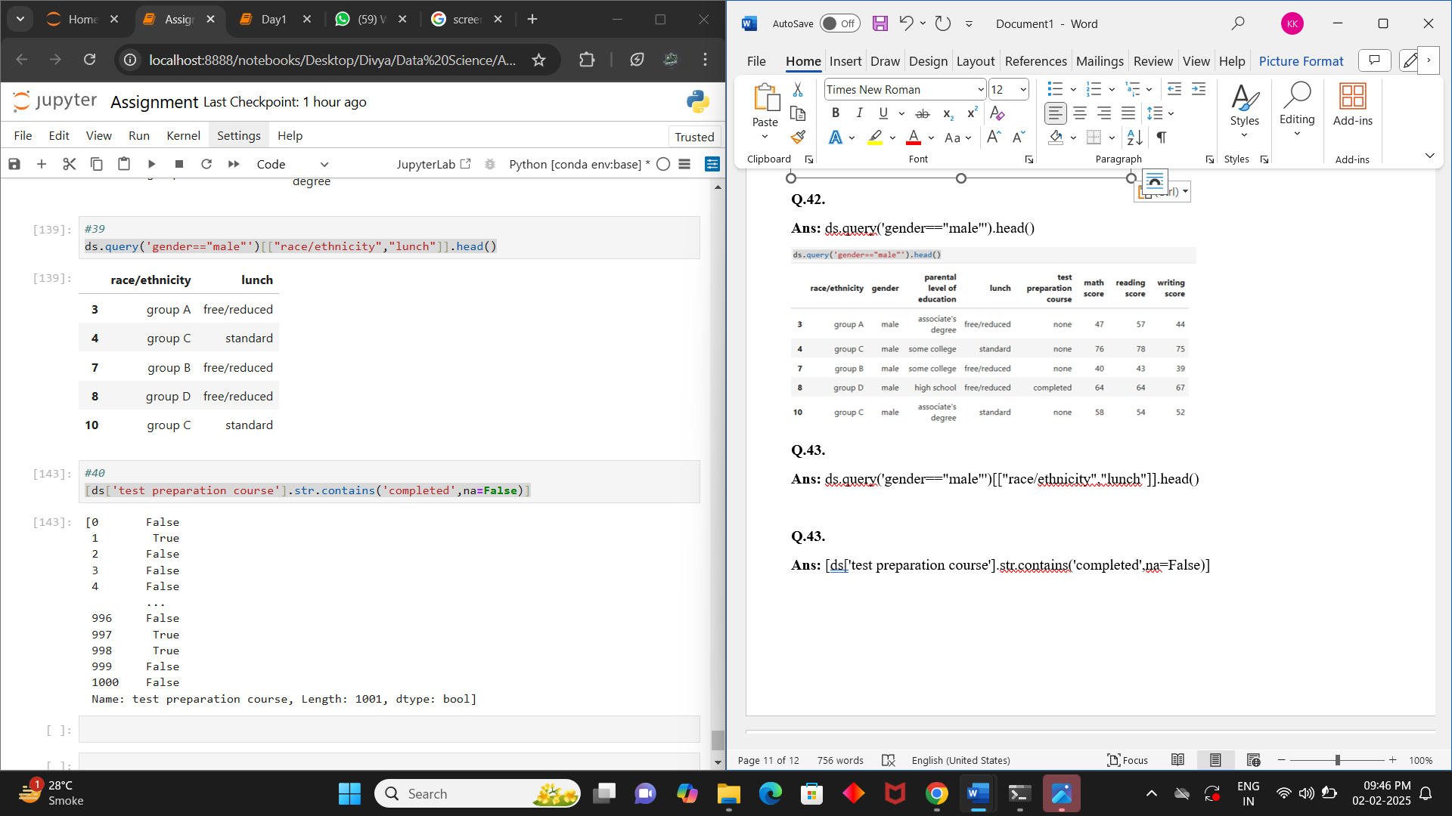

**Q.43.**

**Ans:** [ds['test preparation course'].str.contains('completed',na=False)]

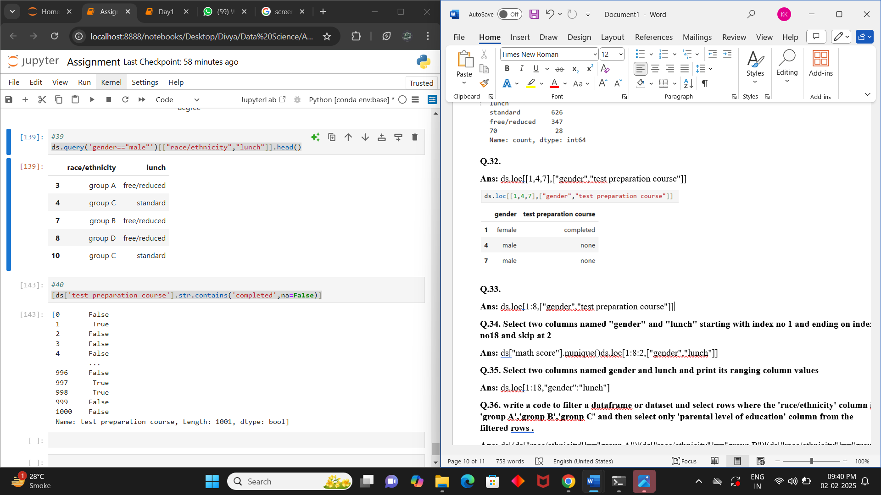

**Q.44.**

**Ans:** ds["gender"]=="male"

